TUẦN 7 TỪ NGÀY 18/10 - 23/10/2021
UNIT 2: SCHOOL
Lesson 3 ( P 20 – student’s book)
A. VOCABULARY (TỪ VỰNG) ( Các em chép bài vào vở)

No | Words |  | Transcription | Meaning
1 | adventure | (n) | / ədˈventʃər/ | Cuộc phiêu lưu
2 | author | (n) | / ˈɔːθər/ | Tác giả
3 | fantasy | (n) | /ˈfæntəsi/ | Kỳ ảo
4 | mystery | (n) | / ˈmɪstəri/ | Bí ẩn
5 | novel | (n) | / ˈnɒvəl/ | Tiểu thuyết

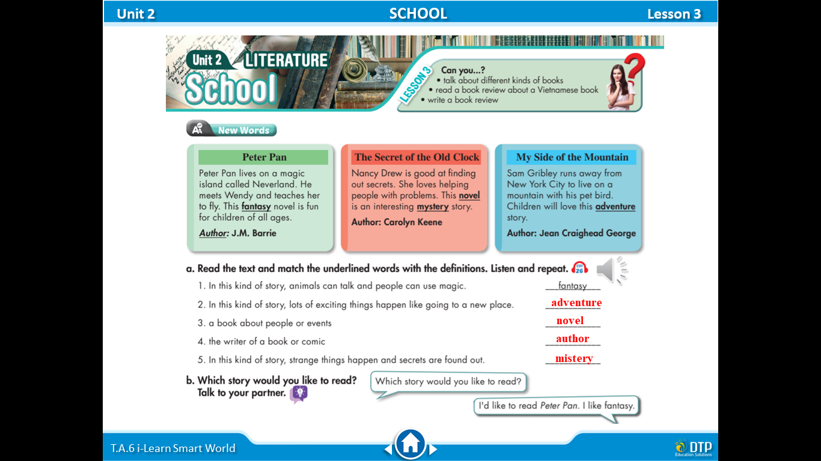

B. Practice:

- adventure (n): Cuộc phiêu lưu ………………………………………………………………………………….………………………………………………………………………………….………………………………………………………………………………………………….
- author (n): Tác giả ………………………………………………………………………………….………………………………………………………………………………….………………………………………………………………………………………………….
- fantasy (n): Kỳ ảo …………………………………………………….………………………………………………………………………………….……………………………………………………………………………………………………………………………….
- mystery (n): Bí ẩn ………………………………………………………………………………….………………………………………………………………………………….………………………………………………………………………………………………….
- novel (n): Tiểu thuyết
………………………………………………………………………………….………………………………………………………………………………….………………………………………………………………………………………………….
- C. Further practice: ( Các em làm các bài tập dưới đây bằng cách chỉ ghi đáp án vào vở)
I. Find the given words below in the table.
Fun Adventure Strange Secret Novel Fantasy
Scary Magic
Author Mystery

II. Supply the correct form of the verbs in brackets
1. My grandmother (give) ______ me a new bike.
2. He (not go) ______ to the movies on Sunday nights.
3. I (go) ______to Daklak province with my parents once a year.
4. I (do) ______ the housework at home to help my parents every day.
5. His mother (cook) ______ in the kitchen now.
6. What______ Mai (do) ______ now? — She (play) ______ in the garden
7.The teacher (read) ______ the dialogue at the moment and we (listen) ______ to her.
8. What______ your father (do) ______ now?
- He (read) ______a newspaper in the living room.
9. Minh (play) ______ soccer every Sunday.
10.What time______ you (go) ______ to bed?
11. How______ she (travel) ______ to work? - She (walk) ______ to work.
12. Kate (play) ______ volleyball every afternoon, but she (play) ______badminton now.
13.We should (do) ______ morning exercises.
14.My brother can (swim) ______ very well.
15. There ( be) ______ many students in the room.
III. Complete each sentence so that it means the same as the sentence above.
Example: I don’t have a television in my bedroom.
There isn’t a television in my bedroom.
1.There are 20 classrooms at my school.
My school_______________________________________________.
2.This table is very dirty.
This is __________________________________________________.
3. His father drives a taxi
His father is______________________________________________.
4. The teacher I like most is Mr. Diên Khánh
Mr Diên Khánh is ___________________________________________.
5.I don’t like maths and physics.
I am not____________________________________________________.
IV.READING COMPREHENSION.
PASSAGE 1: Read the passage below and answer the questions
My school
Hello. I am Khánh Chi. I'd like to tell you about my school. I go to Trần Quốc Toản Secondary School in Tuy Hòa City, Phú Yên Province. My school is not far from my house. I usually walk to school in the morning. My school has four floors. My classroom is on the second floor. There is a computer lab, a library and a music room in my school. My favorite place is the schoolyard. I like to play soccer there. I really like my school.
Question 1: What is the name of Khánh Chi’s school?
______________________________________________________
Question 2: Is her school far from her house?
______________________________________________________
Question 3: How many floors are there in her school?
______________________________________________________
Question 4: Which floor is her classroom on ?
______________________________________________________
Question 5: Where does she play soccer?
______________________________________________________

PASSAGE 2 Choose the option A, B, C or D to complete the passage below
My school is located in the center of Buôn Ma Thuột City, Đắklắk province. It has many electric ___________ (1) which we can use whenever we need. My school also ___________ (2) a large stadium with many row chairs and a___________ (3) covered with roses. And the most ___________ (4) thing about my school is that it has not only an outdoor pool but also 2 indoor pools. In breaktime, we can ___________ (5) books in the library or play games in the video game room.
Question 1: A. cars B. planes C. train D. bike
Question 2: A. have B. has C. is D. are
Question 3: A. classroom B. library C. yard D. garden
Question 4: A. happiness B. boring C. interesting D. noisy
Question 5: A. read B. tell C. watch D. see
PASSAGE 3. Read the passage below and answer the questions
Hello everyone, my name is Mai Lan. I am eleven years old. I come from Quy Nhơn City. Today, I'm happy to tell you about my school. It is a very beautiful school in the center of the city. There are twenty large classrooms and many function rooms. My school has about eighty teachers. Our teachers are very friendly. Students in my school are very good. At school, I learned many subjects such as Mathematics, Literature, English, Art, Music… I like learning English very much because it is very interesting and important to me. Every day at school is a happy day. I love my school very much.
Question 1: How old is Mai Lan?
______________________________________________________
Question 2: Is her school in the countryside?
______________________________________________________
Question 3: How many classrooms are there in her school?
______________________________________________________
Question 4: What is her favorite subject?
______________________________________________________
Question 5: Why does she like that subject?
______________________________________________________

---The end ---

